|  |  |  |  |  |  |
| --- | --- | --- | --- | --- | --- |
| Date | 6-Dec-22 | | | Tester Name | Mayuri Patel |
| Environment | Penfax - Test | | | Login used |  |
| Operating System | Select OS | Version: | Update: | | |
| Software Used | Select Software | Version: | Update: | | |
| Select Software | Version: | Update: | | |
| Release version | 22.4.1 | | | | |
| Title |  | | | | |
| Test Type | Regression | | | | |
| Test Scenario | Process death payment to charity | | | | |
|  |  | | | | |
| Expected Results |  | | | | |
| Pass/Fail | Select | | | JIRA# | N/A |

Describe your steps with screenshots:

Search for a deferred survivor VPB active member who has charity as primary VPB beneficiary

Open that member Profile

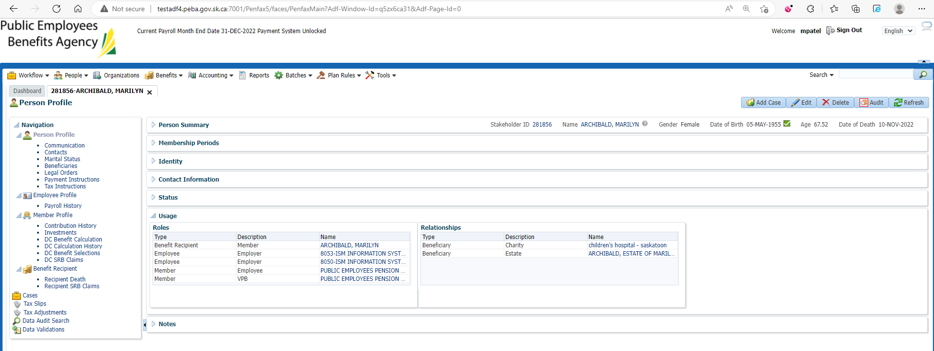

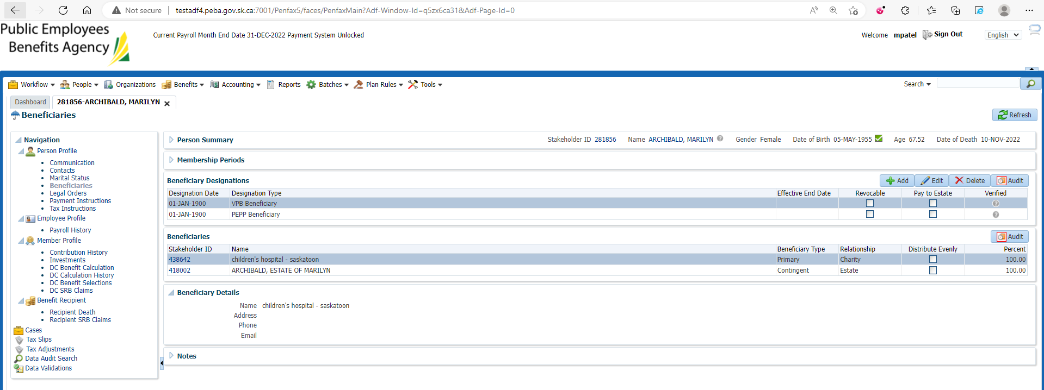

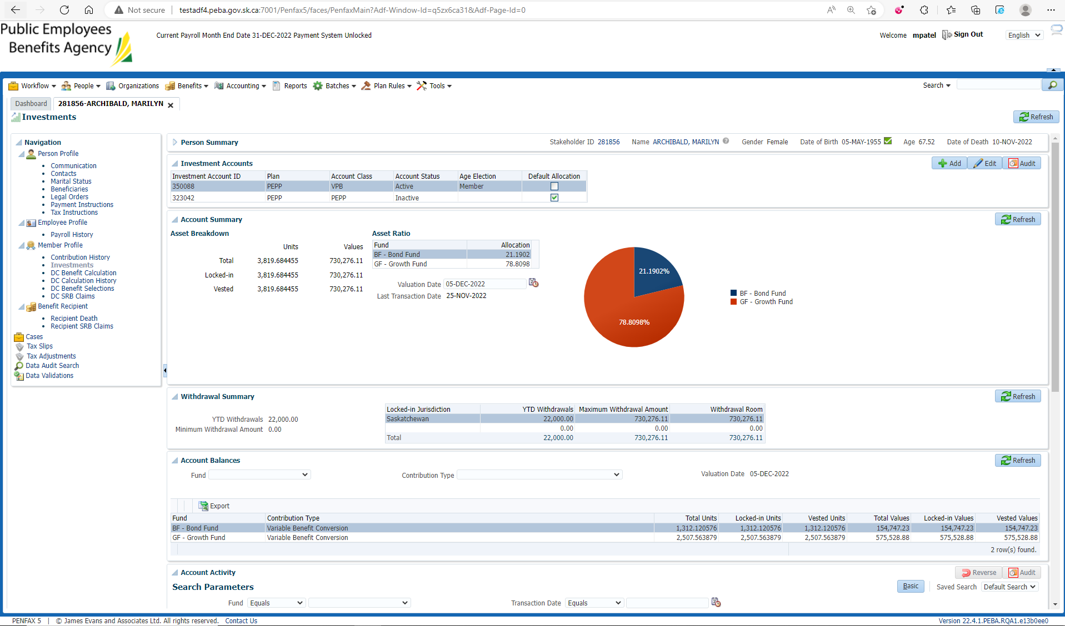

Go to DC Benefit Selection

Add DC Benefit Selection and next

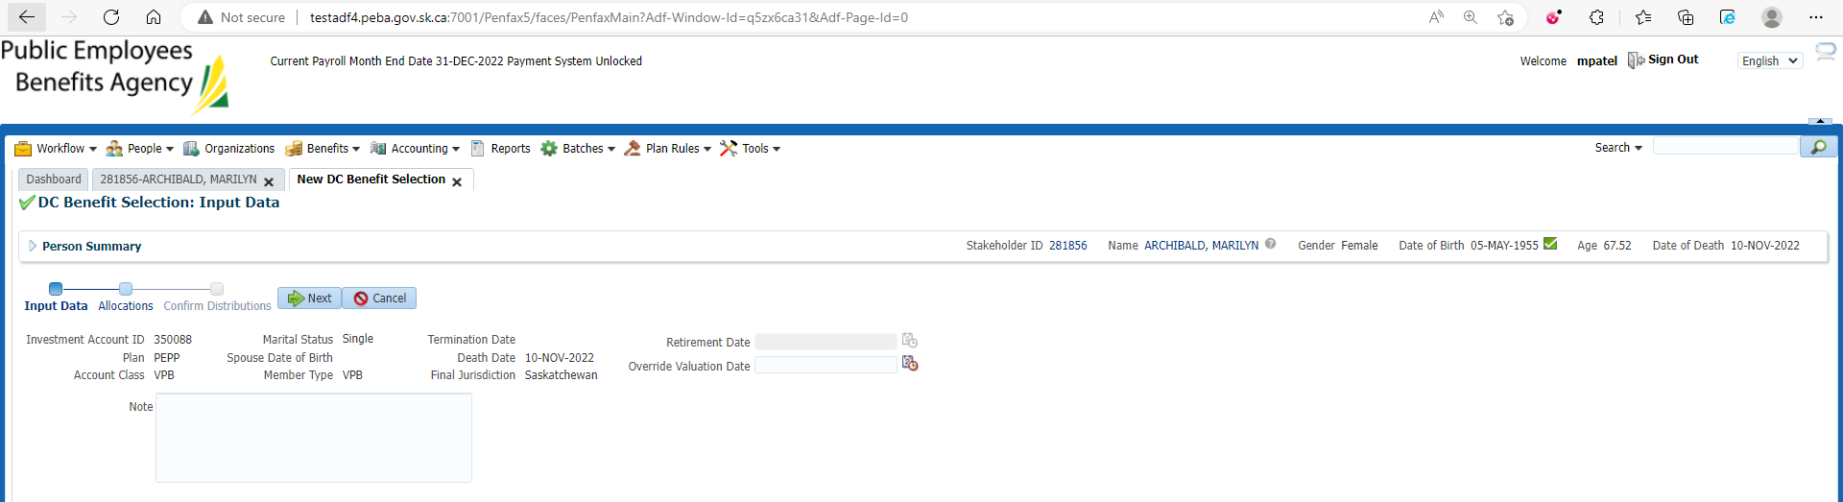

Add allocations and Save

Submit for Approval and Approve it

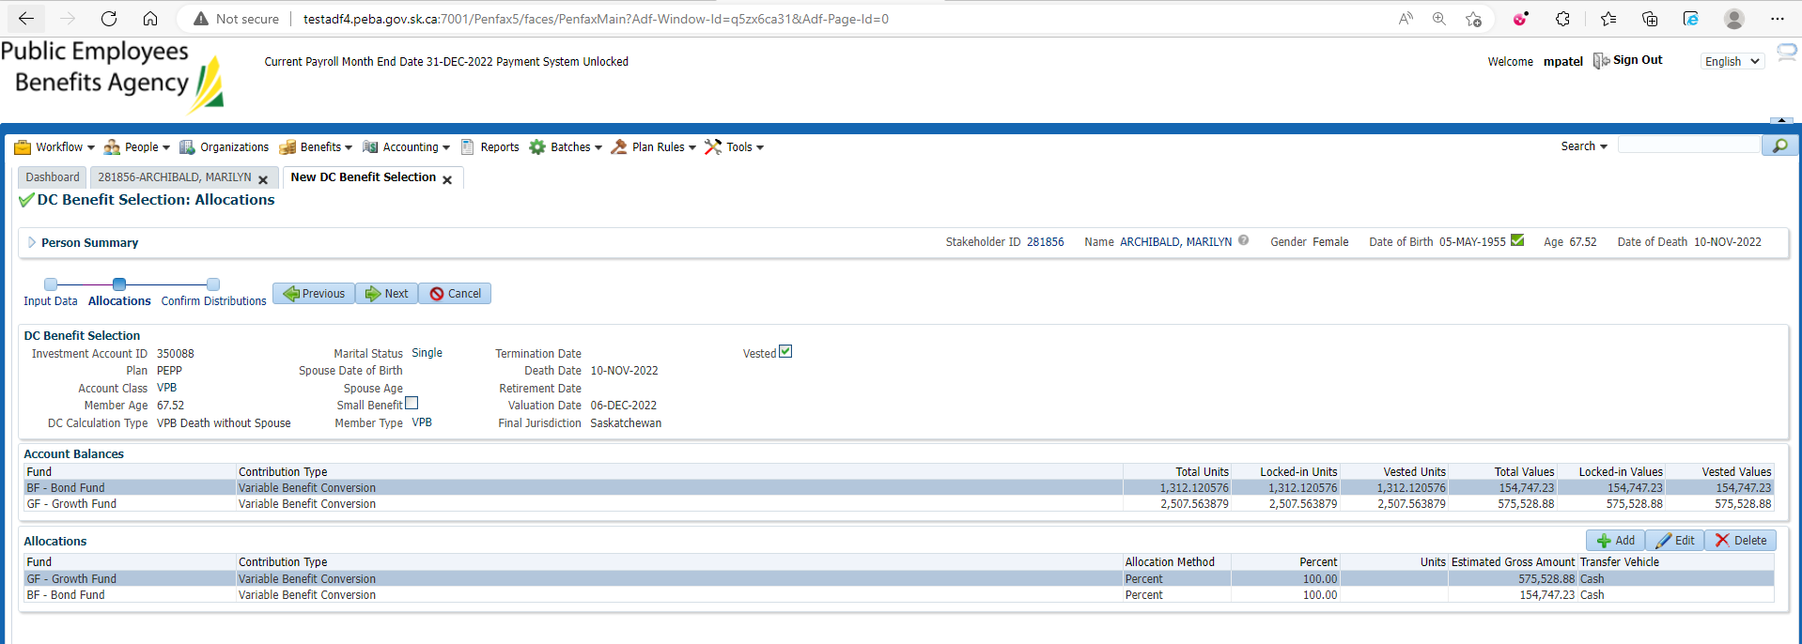

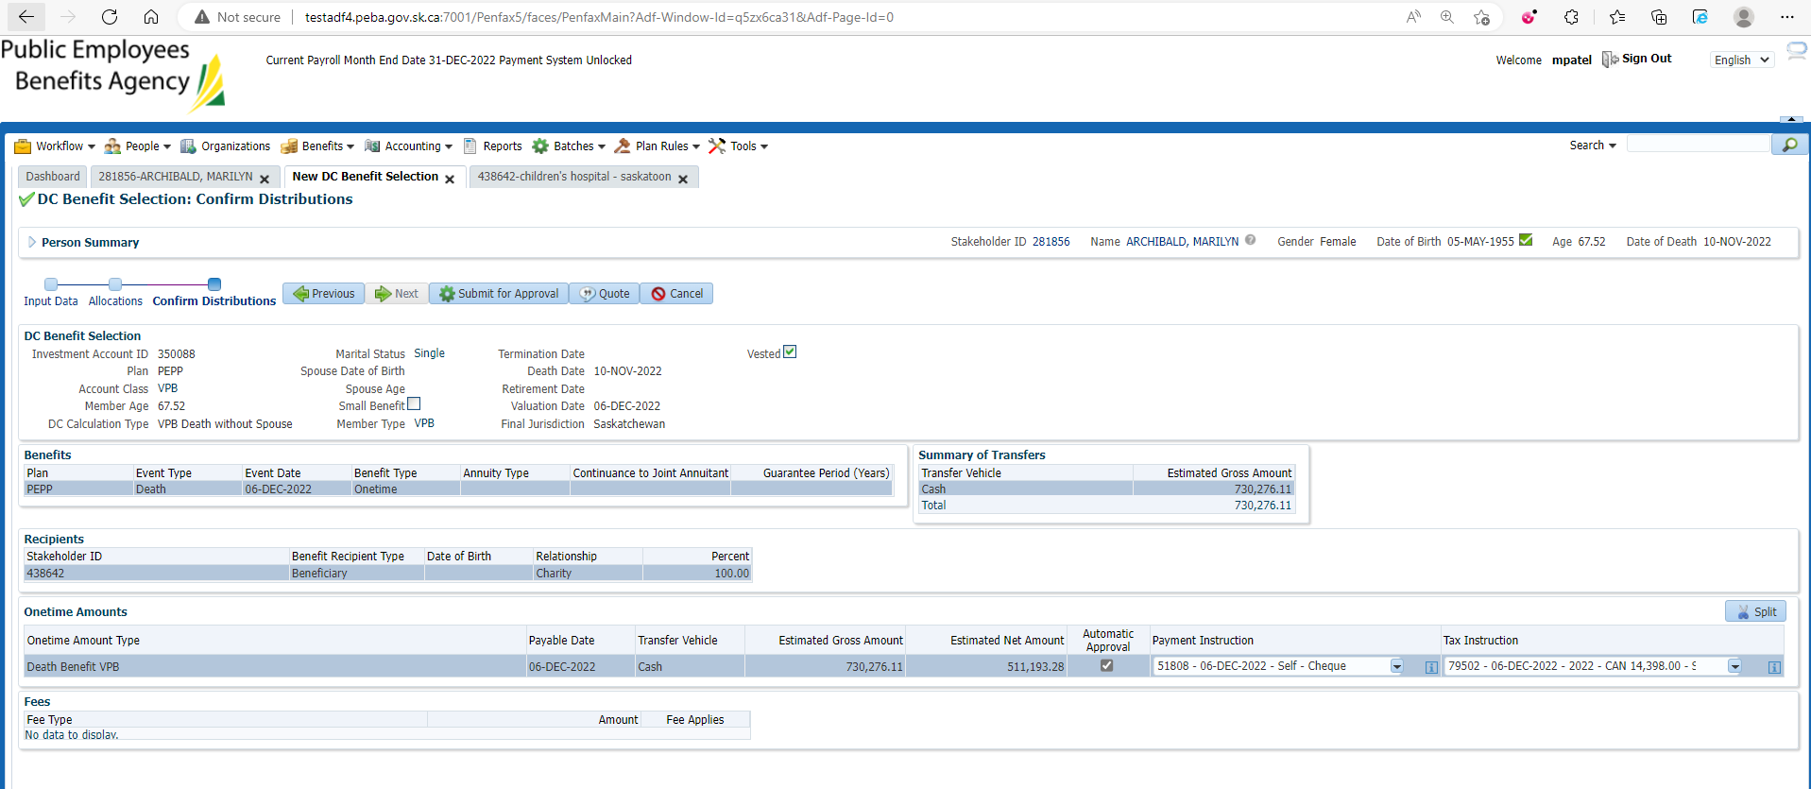

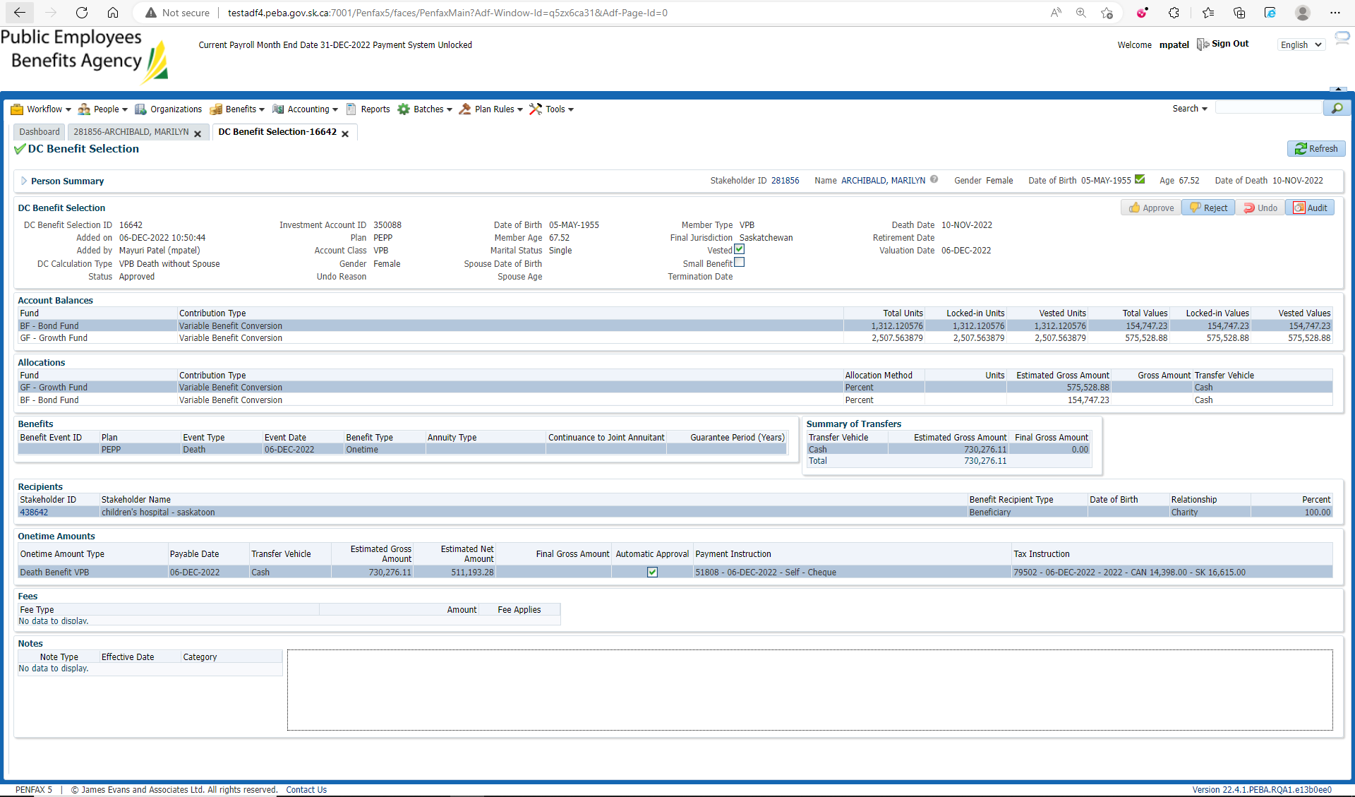

After Overnight PIT Batch

Open beneficiary profile

Benefit Recipient🡪 Onetime Amount

Make sure Death Benefit is processed

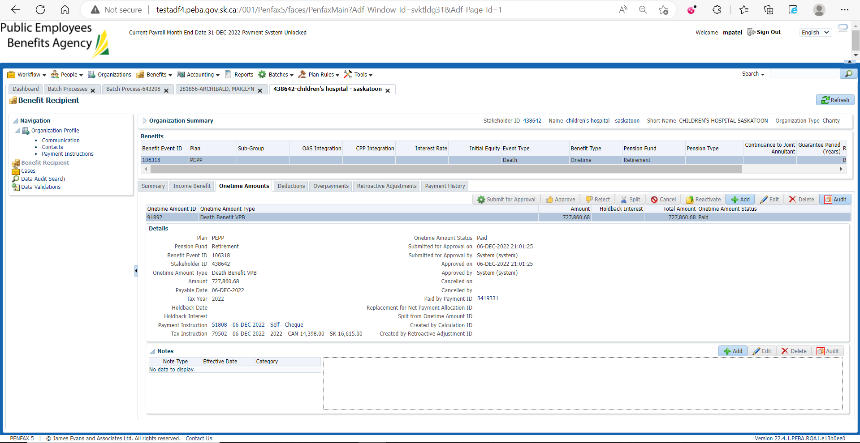

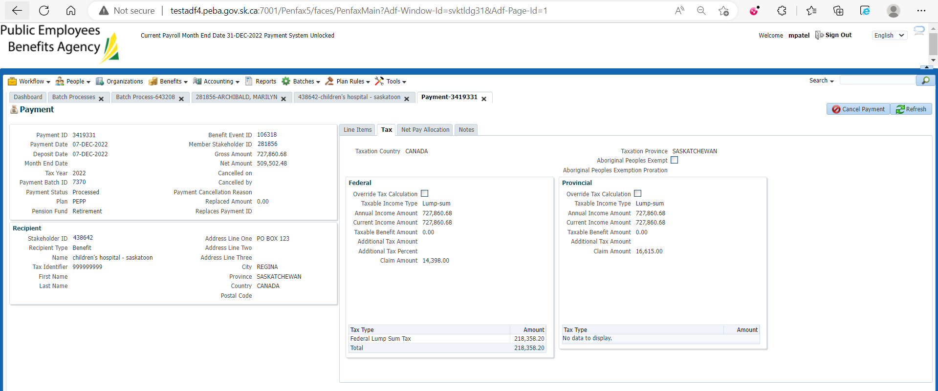

Go to Communications under Person Profile

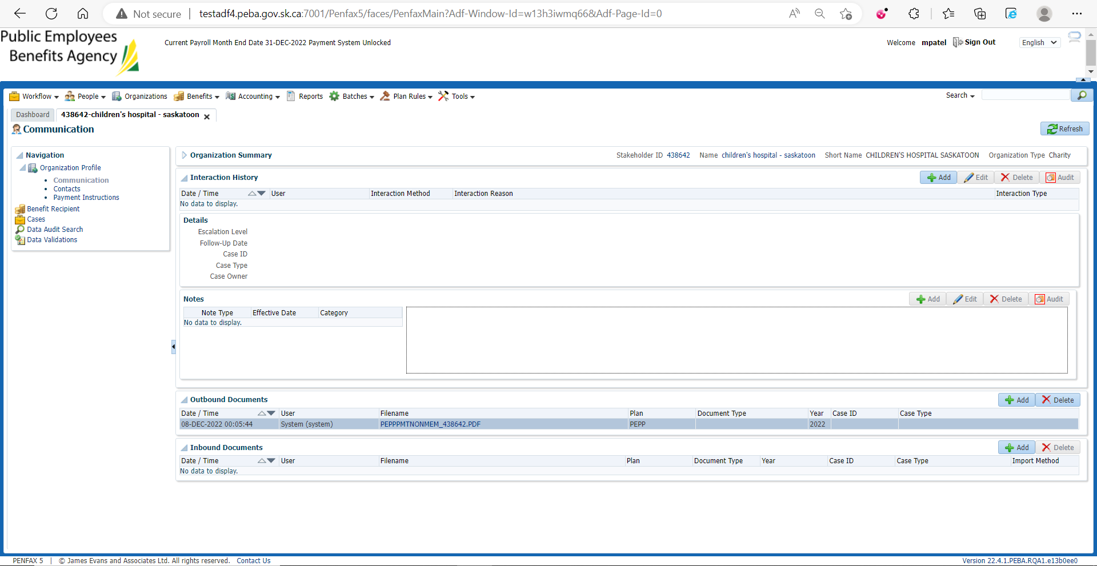

Download & Open PEPP Payment to Non-Member Letter

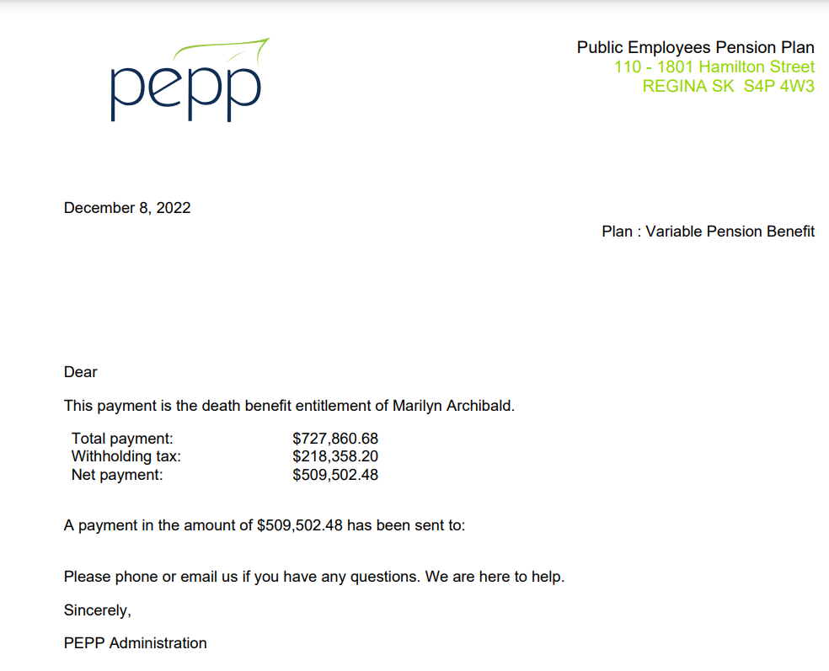

Check the Valuation Report. Go to Batches -> Batch Processes. Search with “PEPP Valuation Report” as Batch Process Type and open the very first record in the list (batch processed a day before).

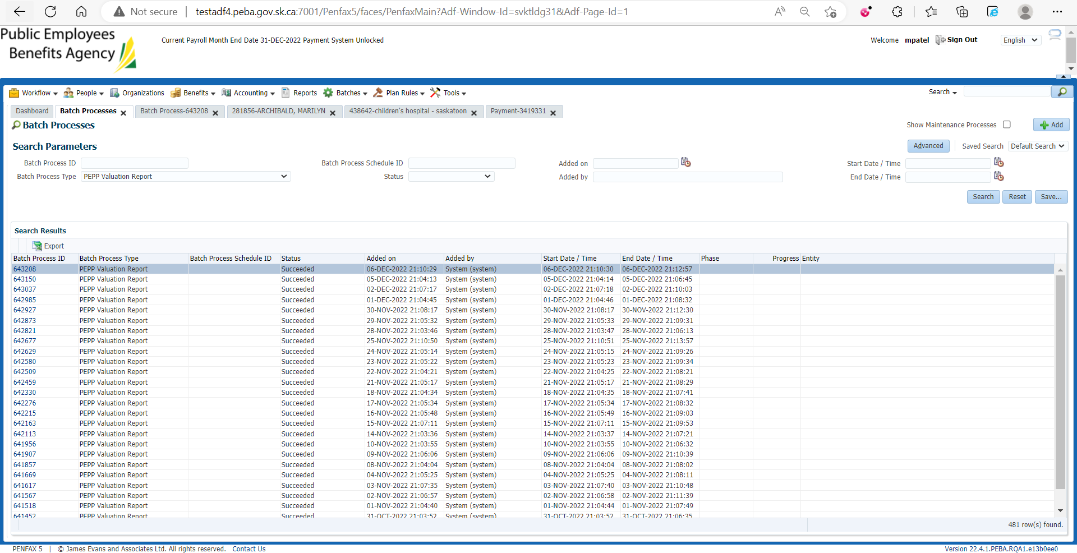

Go to Files tab and open VPB valuation excel

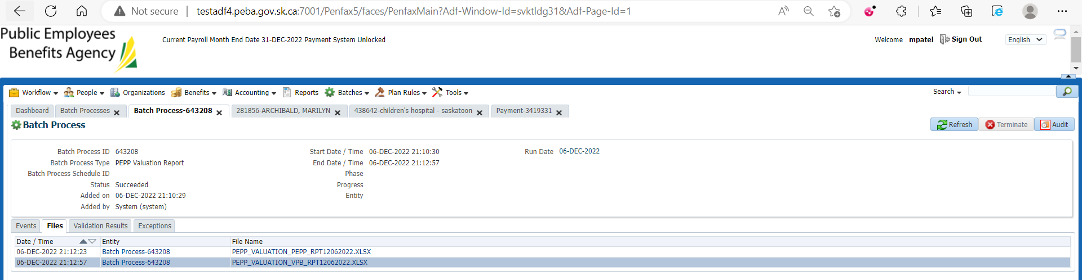

Section Seven

